Captured Items Article
By Andrew Huebner
20th Guards Mechanized Brigade

Late-war reenactors talk about it all the time: war booty, or captured items. It is a topic with never-ceasing interest only rivaled by American GI reenactors who were renown for their gleeful pillaging of war booty. So why did the Red Army man carry any captured gear at all? It is a critical question that goes to the heart of what it meant to be a Soviet soldier, or a combatant for that matter. This article seeks to flesh out the classic dialogue in a new way by arguing for a reexamination of how reenactors should utilize captured items both for educational and immersion purposes. This article does not seek to mandate a specific list of captured gear, nor does it cover all possibilities such as captured weapons. The intent is to provide an academically grounded approach to integrating captured items into a Soviet impression.
Although Russian troops are not stereotyped as ‘war trophy hunters’ like their American counterparts, Russian troops fully took advantage of material culture left in the wake of their battles. Naturally there are many types of items looted from the enemy, but in practice war loot fits into three categories: 1) functionality, 2) trade value, or 3) keepsakes. It is important to line out what each means so to make sense of why items were taken in the first place.
Functionality
Functionality often was the priority for most combat troops in determining whether they wanted to use a specific captured item. It was a commonplace for enemy equipment to be reused and reissued to Russian troops, especially if the condition or quality of an enemy item was considered greater than their current issued equipment. Some men also swapped items out due to impatience with an inconsistent supply line. Fast-moving assault troops often bore the brunt of supply shortages, but these were considerably situational and based on the speed of combat operations. If intending on using this as the basis of an impression, ensure you have specific sources and research!
From buttons to half-tracks, the Red Army reused what the enemy left behind. Binoculars, compasses, and maps frequently fell into officer hands while among all troops items such as flashlights or can openers filled in their everyday needs. Goggles were popular items for mechanized units or officers traveling on dusty or windy roads, while zeltbahns or German K98k ammunition pouches fulfilled roles when the proper equipment was not available. Boots also came in handy as one of the most beloved yet easy to wear out items in a Soviet soldier’s uniform. One soldier, Private Roman Kravchenko-Berezhnoy recounted how he looted from a German boot shop a fine pair of rubber boots, only for his Starshina to horse-trade him the boots for a poorer pair! While most items probably would never have such a fantastic story, it illustrates the desirability of practical captured goods.
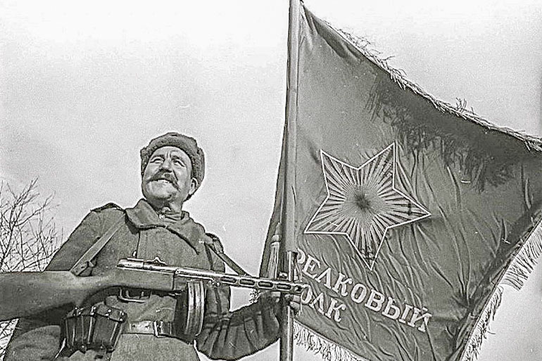
Figure 1 A proud submachine gunner of a rifle division displays his unit's colors. Note the presence of K98k pouches with a PPSH-41. Not every Red Army soldier was issued a proper ammo pouch!
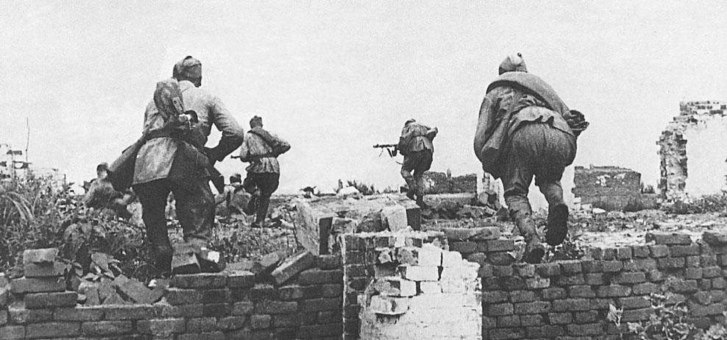
Figure 2 Troops advancing during the 1944 Crimean Offensive, April 1944. Note the use of zeltbahn as a substitute for a proper plasch-palatka. Substitution does not always mean preference!
However, a word of caution: Despite stereotypes of the Red Army as an impoverished army, one must always remember that the Red Army did always provision its troops with their basic needs. By early 1944 even partisan units had the ability to maintain consistent supply chains including receiving plenty of standard army rations, ammunition, and uniforms! Furthermore, what modern people consider to be tactically useful may not be the case at the time. A good example are trophy uniform items. Red Army men did value captured uniform items, but frequently only when the fighting had ceased and they had time to badge up German wool or tropical tunics in Red Army insignia. Camouflage uniforms are another dangerous example, as some units strictly prohibited the use of German uniforms, while others may have adopted it in piecemeal manner at the squad level. Written sources seem uncertain as to the extent of German uniform usage for combat (ex. German leather jackets for tankers), or just for fun aesthetics. For the scrutinizing reenactor, you should be wary of what photos show – think of the context and timeframe! Just because an enemy item can be used, doesn’t mean it is a perfect substitute for standard Red Army equipment!

Trade Value
War booty was also a primary interest for many frontline troops hoping to profit at the expense of their vanquished enemies. Many men and women came from poor areas or homes now ravaged by war, and German loot provided a boost to their own lifestyles both in the military and beyond. Like earlier, good boots were always in demand and highly sought after from captured stocks, especially tall-style jackboots as one officer recalled. Harmonicas and instruments were also highly prized and frequently pillaged, noted Hero of the Soviet Union awardee Dmitriy Loza. Reactions over ‘liberated’ harmonicas ranged from envy to adoration for capable musicians who were often continually supplied with confiscated instruments for their performances. Food was also a common item for speculation, such as fruits or alcohol highly desired by all troops, and stories abound of Red Army soldiers living more and more on captured food by the end of the war. Items from wealthy landowners or upper-class manors were always eyed by an army taught to hate exploitative and materialistic capitalists. Soldiers felt less guilty about such blatant acts of stealing when considering how their own homeland had been pillaged by the Wehrmacht in 1941 through 1943.
Indeed, men and women frequently sought after valuables such as fine clothing, jewelry, or art. Most notably, men adored nice watches and seemed to be in an eternal frenzy looting watches. Some Axis accounts, such as from Italian troops on the Don front in 1942, even note Soviet troops rushing to immediately demand watches from sometimes still-armed prisoners of war! Women fancied the fine dresses and clothing from Germany, using more practical pieces such as undergarments and sending home skirts and coats for when they return home. Yet another, more humble reason exists for capturing certain German items: to simply provide for the everyday needs of loved ones back home who had little money to spend on themselves. Sergeant Aglaia Borisovna Nesteruk recalled how troops entering Germany collected items for their families back home. “We got permission to send packages home. Soap, sugar…Someone sent shoes. Germans have sturdy shoes, watches, leather goods. Everybody looked for watches.”
The Soviet Union did prohibit trade, or speculation, as the crime was called by the state police. Speculation, especially of Red Army supplies, was a considerable crime in the Red Army punishable by court-martial. However, evidence suggests the Red Army men were not shy about participating in speculation in the material-rich world of a combat zone. In fact, the Red Army during the war valued any materials worth reusing or helping please the demands of troops. One notable example is the decree allowing for mailing war loot, issued December 1944 and implemented on January 1, 1945. The decree permitted frontline troops to mail back 5 kilograms once a month with no shipping cost. Parcels were still subject to scrutiny, including forbidden items such as weapons, liquids, medicine, and perishable goods, as well as any written notes or messages that could bypass censorship. The parcel system never formally sanctioned looting, but many soldiers from then on started more vigorously searching for valuables to send back home.
Keepsakes
Finally, souvenirs were always highly valued, but far rarer for captured items. Token items often were imbued with personal meaning of a time, place, or event in a soldier’s military career. For centuries it was a key element of the soldierly experience to take items from a vanquished foe in battle, such as helmets or swords to take directly back home. However, the increasingly nationalized and industrialized state of war increased the frequency and duration of battles beyond what was considered significant for soldiers of the past. The defeat of Wehrmacht armies were without a doubt an achievement for the Red Army, but to the everyday Red Army soldier, battles could blend together. The question goes back to whether a Soviet soldier wished to remember a particular event, and the manner such a keepsake might take. For many Soviets trench made items or battlefield pieces such as shrapnel served commemoration purposes.
Nevertheless, some men attempted to take back with them souvenirs of a fallen empire, and the variety is nearly endless. Flags, medals, pieces of Nazi statues, such items served no purpose other than to commemorate victory. For a good number, headgear, be it German, Japanese, or for a few, American, were hefty but interesting war trophies to acquire or send back home. Another notable example are ceremonial daggers, which could be seen with celebrating troops as accessories for their kits. Still, during wartime, it was exceptional for Red Army men to want to carry too much with them for the sake of memories – most war trophies of this kind occurred once Red Army troops made it into the Axis countries.
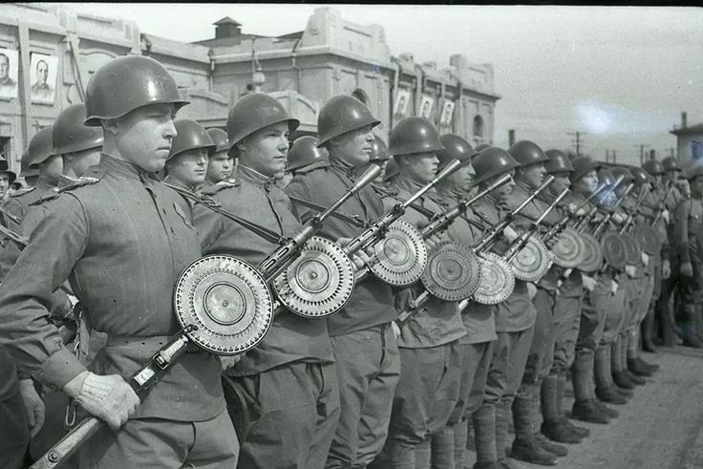
Figure 3Soviet machine gunners in a victory parade in Manchuria, 1945. Note the number of Japanese helmets mixed with the standard Russian helmets!
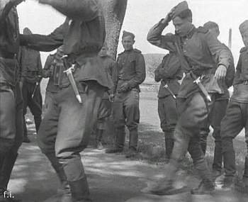
Figure 4Soviet troops dancing near the Elbe River, April 1945. Note the number of German dress daggers.
Let’s use a common reenactor trope as a case example for solidifying the ideas presented in this article: the German belt buckle. In recent years it has come into popularity for a number of reasons, but here it perfectly fits all three of the categories for the use of captured items.
- First, it is a functional item for daily use for a sturdy equipment belt. Soviet equipment belts were generally good quality, but foreign made ones such as American lend-lease ‘garrison’ belts or German-made leather ones with a metal buckle were seen as a good substitute.
- Secondly, belt buckles were true war booty with trade value. It may seem mundane, but a captured belt buckle proved a soldier had been at the frontlines and likely went face-to-face with the enemy. For an army where masculinity and individual heroism for a grand cause were praised, an enemy belt buckle showed the mettle of a fighting Soviet man. It could, and often did, get easily traded to rear echelon troops for goods.
- Finally, it is a highly prized souvenir by many Allied armies for its intricate design and symbology. German belt buckles were well-known for their reichsalder (imperial eagle), swastika, and most notably of all, their military mottos such as ‘Gott Mit Uns’. It should be noted that the Soviet state prohibited the ownership of items with Nazi party symbols as such symbols were destined to be destroyed as a part of the socialist war on fascism. Therefore, unlike American armies who wished to preserve the identity of a fallen enemy for the future, the Soviet soldier had little qualms (or choice) in defacing a buckle, whether through crude or artistically creative methods.
However, do note other items fit all three categories, such as wristwatches. Such multi-meaning items are ideal for reenacting in the same way they were perfect for Soviet soldiers during the Second World War.
For a reenactor, it is up to their own interpretation as to what items they want to take with them. However, it should be noted that different units had different approaches based on their combat experience, leadership, and primary group culture. Some units discouraged captured items, while others freely permitted looting so long as it did not interfere with a unit’s effectiveness. The best policy on captured items is threefold:
1) examine the context of your impression to determine what was used for a specific operation or timeframe,
2) ask your NCOs or your immediate ranking superiors on the viability of an item, and
3) when in doubt, keep it minimal and keep it small.

We hope this article has provided some thoughtful framework on the complicated topic of captured item usage. Again, it is not primarily prescriptive on specific items, but can provide a structure for others to analyze the viability of enemy items in an individual impression.

This model is based off of one used in Seth Givens’ “Liberating the Germans: The US Army and Looting in Germany during the Second World War” War in History, 21:1, Pg. 33-54.
Bessonov’s Tank Rider,
Kravchenko-Berezhnoy, Victims, Victors, 230-231
For more on the Soviet partisan movement and its equipment or supply lines, see Alexander Hill. The War behind the Eastern Front: The Soviet Partisan Movement in North-West Russia, 1941-1944. Frank Cass, 2005.
Evidence of orders against the proliferation of German uniform items within the 89th Guards Rifle Regiment, 28th Guards Rifle Division. Note the timeframe, when the fighting had seemed to cease. Other examples exist from early April 1945. The existence of the documents proves 1) Soviet soldiers had been indiscriminately using German uniform items as they came across them during the Berlin operation, and 2) it was considered so widespread efforts were put down to ban its use on the excuse all uniforms must be turned over to so-called ‘trophy units’ for categorization and recycling. One order reads as follows: “Cipher message #936 from 47 Army HQ issued 08.05.1945 at 03:23 AM To all the Corps and rear units commanders with the copy to the Commander of the Front HQ. There have been registered many cases of dress code violations by army's personnel in recent period: civil clothes, mixed uniforms, and German army uniform. I ORDER: 1) To convey the dress code regulation to whole officer corps, and demand their meticulous adherence. 2) All the civil dress items, as well as German army uniforms are to be immediately removed and delivered to the trophy depots. 3) All the commanders are to inspect their units during the period 8-10 May 1945." “Order from 1st Department of 28 Guards' Rifle Division, 89th Guards Rifle Regiment, 47th Army HQ, 8 May 1945”, sourced from Министерство обороны Российской Федерации, Pamyat Naroda. https://pamyat-naroda.ru/
Brandon M. Schechter. The Stuff of Soldiers: A History of the Red Army in World War II through Objects. Cornell University Press, 2019,
Dmitriy Loza. Fighting for the Motherland: Recollections from the Eastern Front. Edited and Translated by James F. Gebhardt. University of Nebraska Press, Pg. 145
Stuff of Soldiers, 231
Hope Hamilton. Sacrifice on the Steppe: The Italian Alpine Corps in the Stalingrad Campaign, 1942-1943. Casemate, 2011, pg. 134
Svetlana Alexievich. The Unwomanly Face of War: An Oral History of Women in World War II. Translated by Richard Pevear and Larissa Volokhonsky, Random House, 2017, pg. 308.
Stuff of Soldiers, pg. 228

